LESSON 1 – INTRODUCTION TO CARPENTRY MEASUREMENT
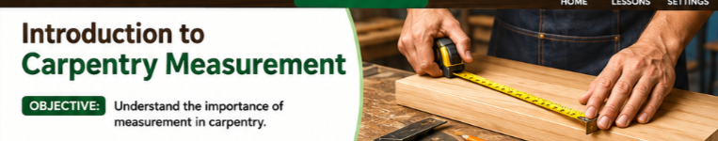
(PALAGYAN PO NG PICTURE HERE, SAMPLE PROVIDED)
Learning Objective
At the end of this lesson, learners should be able to:
Explain the importance of accurate measurement in carpentry and identify common measurement terms and units used in carpentry.

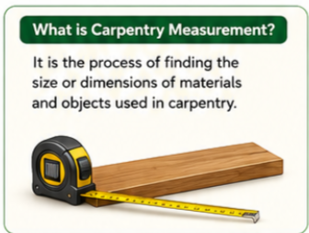
What is Carpentry Measurement?

(SAME HERE PICTURE RELATED TO CARPENTRY MEASUREMENT, SAMPLE PROVIDED PERO IKAW NA PO BAHALA)

Carpentry measurement is the process of finding the size or dimensions of materials and objects used in carpentry.
Carpenters measure materials before cutting, joining, or constructing them. Measurements help ensure that the materials have the correct size and fit.

Example:
If a carpenter needs a piece of wood that is 2 meters long, the carpenter must measure the wood accurately before cutting it.

📌 Remember:
Measure first before you cut!

What is Mensuration?
(PICTURE RELATED TO MENSURATION, SAME SA NASA UNAHAN, IKAW NA DIN PO BAHALA)
Mensuration is the process of measuring the size, length, area, volume, or other dimensions of an object.
In carpentry, mensuration is important because carpenters need to determine the correct dimensions of materials and structures.
Example:
A carpenter may need to determine:
- The length of a wooden board
- The width of a table
- The height of a cabinet
- The thickness of a piece of wood

👉 Simple meaning:
Mensuration = measuring things and finding their dimensions.

Why is Accurate Measurement Important?

(PICTURE)

Accurate measurement is very important in carpentry because it helps produce correct, safe, and quality work.
Accurate measurement helps to:
📏 1. Get the correct size
Materials can be cut according to the required dimensions.
🔨 2. Prevent mistakes
Correct measurements reduce errors during cutting and construction.
🪵 3. Avoid material waste
Accurate measurements prevent unnecessary cutting and wasting materials.
🏠 4. Make parts fit properly
Proper measurements help wooden parts fit together correctly.
✅ 5. Produce quality work
Accurate measurements result in neat and precise carpentry projects.

⭐ Remember:
A small measurement error can affect the entire project.
Common Measurement Terms

(PARANG GANITO PO PERO INDIVIDUAL SILA)
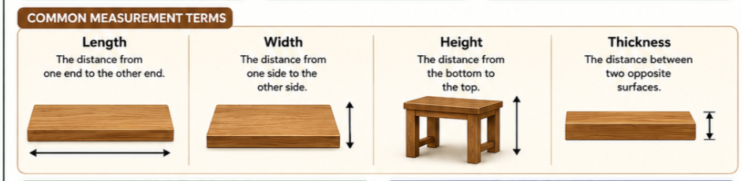

Carpenters use different terms when describing the size of an object.

📏 Length
Length is the distance from one end of an object to the other end.
Example:
The length of a wooden board is 2 meters.

↔️ Width
Width is the distance from one side of an object to the other side.
Example:
A wooden board may have a width of 20 centimeters.

↕️ Height
Height is the distance from the bottom to the top of an object.
Example:
A cabinet may have a height of 1.5 meters.

🪵 Thickness
Thickness refers to the distance between two opposite surfaces of a material.
Example:
A wooden board may have a thickness of 25 millimeters.

Measurement Systems
There are two common measurement systems introduced in this lesson:

A. Metric System (SI)
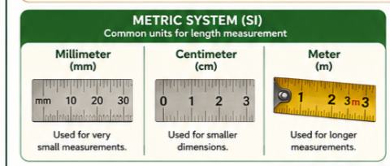

(PARANG GANITO DIN PO EACH DIN HINDI GANYAN, IKAW NA BAHALA KUNG ANO GAGAWIN MO PO)

The Metric System, also called the International System of Units (SI), is commonly used for measurement.

The common units are:
Unit | Symbol | Example
Millimeter | mm | 5 mm
Centimeter | cm | 20 cm
Meter | m | 2 m

📌 Millimeter (mm)
A millimeter is a small unit of length.
It is useful for measuring small dimensions, such as the thickness of materials.
Example:
A board may be 25 mm thick.

📌 Centimeter (cm)
A centimeter is larger than a millimeter.
It can be used to measure smaller objects and dimensions.
Example:
The width of a board may be 20 cm.

📌 Meter (m)
A meter is used to measure longer distances or larger objects.
Example:
A wooden board may be 2 m long.

B. English System
(IKAW NA BAHALA KUNG ANO GAGAWIN MO PO)
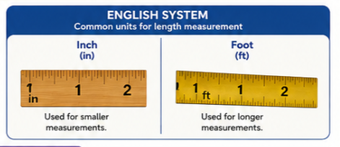

The English System uses units such as inches and feet.
Unit | Symbol | Example
Inch | in | 12 in
Foot | ft | 6 ft

📌 Inch (in)
An inch is a unit used to measure length.
Example:
A piece of wood may be 12 inches long.

📌 Foot (ft)
A foot is a larger unit than an inch and is commonly used to describe longer dimensions.
Example:
A board may be 6 feet long.

⭐ LESSON SUMMARY
Before moving to the next lesson, remember:
📏 Carpentry measurement helps determine the correct size and dimensions of materials.
📐 Mensuration is the process of measuring and finding the dimensions of objects.
✅ Accurate measurement helps prevent mistakes, reduce waste, and produce quality carpentry work.
Common terms: Length, Width, Height, and Thickness.
Metric units: mm, cm, and m.
English units: in and ft.

🔨 CARPENTER'S REMINDER
“Measure accurately before you cut!”

